The Use Of Language Games In The Teaching Of Arabic Language - A First Year Primary School Model

Saida Sadoudi University of Boumerdes M'hamed Bougara (Aleria). s.sadoudi@uni-boumerdes.dz

Received: 02/2024 Published: 07/2024

Abstract:
Linguistic games are considered effective teaching and learning strategies that are used to develop a child's linguistic performance, especially in the early stages of learning. This method of teaching makes the learner more involved and participative in the educational situation, as it is an activity that the learner practises using their different senses. Language games also help with correct pronunciation, fluency and enrichment of the learner's vocabulary. They also help to overcome some linguistic difficulties such as sound discrimination, visual discrimination of similar letters and other obstacles that hinder the learner during the learning process. Due to their effective significance, language games have been incorporated into the field of education, as they are a method that combines fun and usefulness, helping both the teacher and the learner.
This research paper aims to shed light on the reality of Arabic language teaching at primary school level and to determine the effectiveness of language games in improving language performance and enhancing comprehension among learners, in addition to stimulating active learning and effective participation by providing a fun and attractive learning environment. It also promotes social cooperation among learners and interaction through group activities, which is appropriate for this age group.
The research question is formulated as follows To what extent do language games contribute to the teaching and learning of Arabic among first grade primary school students?
This main problem includes the following sub-questions:
- What are language games? What are their benefits? Does teaching through language games lead to an improvement in the linguistic and cognitive performance of learners at this level of education?
Based on the previous questions, a number of hypotheses were proposed:
- Language games are one of the best pedagogical tools that help to learn Arabic in an integrated framework in a simple and at the same time enjoyable way.
- Language games play an effective role in teaching and learning Arabic.
- Language games are an important strategy that helps the learner to acquire the Arabic language at all its phonological, morphological and syntactic levels.
- Language games are one of the most modern methods that can be used to improve the teaching and learning of Arabic.
This study aims to demonstrate the importance of language games in teaching the Arabic language by combining language learning and entertainment. Therefore, language games have been designed to achieve educational goals as they are in line with the age group and their general psychological, physical, intellectual and mental characteristics, etc. Playing will result in enhanced learning driven by desire, enthusiasm and interaction. The importance of this study lies in the following points
- Language games attract learners’ attention and make the learning process more effective and enjoyable, thus increasing their desire to learn Arabic and actively use it in different situations and circumstances.
- Language games are suitable for different age groups and educational levels of learners and go beyond the boring traditional methods.
- Language games contribute to language acquisition as they help to expand learners’ vocabulary and develop their ability to construct sentences and use the language in a more practical way.
- Language games play an important role in developing a well-rounded personality in learners and make them more interested in learning.

Keywords: Education - Language games - Arabic language - Primary 1.

Firstly, language games and their educational importance and benefits in the early stages of education.

Introduction:
Education is one of the most important concerns that strive to achieve the best curricula and effective strategies in teaching. The latter is of great importance in all global educational curricula and systems that work to select the most appropriate methods for learners in terms of their tendencies, age and needs. Therefore, it has become a necessity and an essential requirement to focus on methods that achieve the greatest competencies. The more the method is stimulating, exciting and related to the characteristics of the learner, the more successful and capable it is of teaching the language to be learnt. Among these methods, we find the method of “language games”, which are no longer just a means of entertainment or leisure, but have become one of the most effective strategies in education, especially in the early stages.

1- The concept of language games:
One of the best definitions of a language game is that given by James G. Gibs, who describes it as an activity carried out by pupils, cooperating or competing, to achieve their goal within the rules set. It is also defined as a set of linguistic activities and scientific practices that the teacher prepares and the learner performs in an exciting educational way, with the aim of developing some aspects of performance, languages and acquiring some Arabic language skills, including creative oral expression.
Through all these definitions, we can conclude that language games are a linguistic activity and techniques used to teach and acquire language skills for the child and provide them with a large linguistic stock, in addition to developing their linguistic competence. This is done by practising the method of excitement and competition between them, as well as by following a clear plan, based on studied scientific foundations, to achieve the desired goals, which help the learner to pronounce correctly, enrich the linguistic stock, master expression and develop perception and discrimination.

2- Benefits of language games in the teaching-learning process:
The benefits of language games are manifold as they encompass all aspects of the individual and society from psychological, cognitive and social perspectives.

2-1 Psychological benefits:
Language games are of immense importance because of the tremendous benefits they offer to the learner’s psychology. These benefits include:
- They capture attention and facilitate learning.
- They provide an opportunity to express desires, needs and inclinations.
- They help to fulfil certain psychological needs, such as the need for freedom and the opportunity to exercise leadership.
- They relieve psychological and nervous tension, increase self-confidence and improve morale.
- They promote motivation to learn.

2.2. Intellectual benefits:
God Almighty has distinguished us from other living creatures by giving us the faculty of reason, which comprises a set of cognitive mental processes that ensure awareness, thought and language, as well as everything related to the mind and thought. We find a series of benefits specific to language games at the intellectual level, which in turn contribute to the development of the learner’s cognitive abilities. They also help to achieve the following pedagogical objectives:
1. Accustom the learner to thinking quickly and relying on self-learning.
2. Train the learner to solve problems and engage in exploratory processes.
3. Provide opportunities for participation in social activities and interaction with others.

2-3 Social benefits:
The learner is a social being who influences and is influenced by peers. Language games play an important role in this process of influencing and being influenced in the school context and have many benefits, including:
1. The ability to overcome tensions that may arise within the group.
2. Improving the behaviour of the learners, where they have to respect their peers, take turns and accept the outcome of the game, whether they win or lose. It also teaches discipline and respect for the rules of the game.
3. To prepare the learner for social life, which is also governed by a set of rules.

2-4 Physical benefits:
Language games have a positive effect on the physical aspect of the learner and their benefits include:
1. It helps physical growth, strengthens the muscles and helps the body get rid of excess secretions. It also frees the body from physical tension and muscle fatigue.
2. Mastering movements, forming skills and achieving sensorimotor coordination necessary for language learning. It also helps in the pursuit of knowledge and the development of mental processes, as well as reducing psychological stress in an atmosphere of enthusiasm and desire to learn, as shown in the following diagram.

Figure (2): Benefits of language games

3- Characteristics of language games and their pedagogical significance³:
Every modern teaching method is characterised by its effectiveness and unique features. The teaching method of language games has the following characteristics:
It is a means of relaxation and freedom, where the learner plays without any external influence or pressure from the environment, and it also makes them love learning.
It stimulates learners’ motives for purposeful educational activity, improves their skills, modifies their behaviour and develops their scientific and linguistic skills through practice and teamwork.
It is an educational and developmental tool and is considered to be one of the most effective tools in the education and development of the learner.
It promotes organised, goal-oriented thinking.
It provides flexibility in teaching and is a foundation for the learner’s linguistic growth.
It fosters a spirit of teamwork and positive cooperation through group activities and the creation of a competitive atmosphere.

4- Functions of language games:
Language games have roles and functions which include:
Providing the learner with experiences that are closer to practical reality than any other teaching method, as the learner gets to know and make decisions about the problems they will face in the future. In this way, games reduce the gap between what happens in the classroom and what happens in everyday life.
Help the teacher to develop a new strategy for dealing with individual differences between students by providing different skills at different levels, so that most of the class can benefit.
Helping to refine the personality of the learner to become more involved and responsible in the learning process, as they are the implementers and planners of the educational situation, striving to successfully complete the assigned task.
Eliminate the boredom, tedium and inattentiveness that often affect students. Therefore, a skill can be presented in the form of a game or simulation, which helps to acquire this skill more quickly.

5- Aims of language games:
We can summarise the main aims of language games in the following diagram:

Objectives of Language Games
Physical goals
Cognitive goals
Social goals
Emotional goals
Skill goals
- Training the muscles
- Training the senses
- Physical health
- Neuro-muscular coordination
- Developing mental processes
- Exploration and innovation
- Developing thinking
- Communication with others
- Learning the laws and systems of society
- Providing live situations
- Motivation and acceptance of failure
- Self-expression and meeting desires and needs
- Forming personality and eliminating repression
- Speed, accuracy, and proficiency
- Skill in linking the tangible with the abstract
- Problem-solving and inquiry skills

Figure (3): Objectives of Language Games

From this diagram we can see that language games have several objectives. First, there are physical objectives related to the learner’s body, such as muscle training and sensory development. Second, there are cognitive objectives related to exploration and the development of thinking. Thirdly, there are social objectives which relate to the learner’s relationship with others and society. Fourthly, there are affective objectives related to the development of the learner’s personality and identity.

6- The importance of language games:
Language games play an important role in language learning and acquisition, as they significantly facilitate the language learning process. The importance of language games can be outlined in the following points:
- Language games are motivating and challenging and encourage learners to interact and communicate.
- They allow the development of the four language skills: listening, speaking, reading and writing.
- Language games encourage learners to use language in a creative and natural way and help to improve communicative competence. They also help the teacher to organise and harmonise the classroom.
- They develop the level of dialogue and conversation between learners, especially in the primary stage where the teacher can turn stories into a performance for the learners to act out.
- They create a sense of relaxation and enjoyment for the learners and help them to absorb the anxiety and tension of language learning.

Secondly: An applied study on the use of language games in teaching Arabic to first-year primary school students.

1. “The game of distinguishing between the sun [al-] and the moon [al-]”: The game was implemented through the following steps:
Placing two models, the first in the shape of a moon and the second in the shape of a sun, then placing the letters of the sun in the model specific to it and the letters of the moon in the model specific to it.
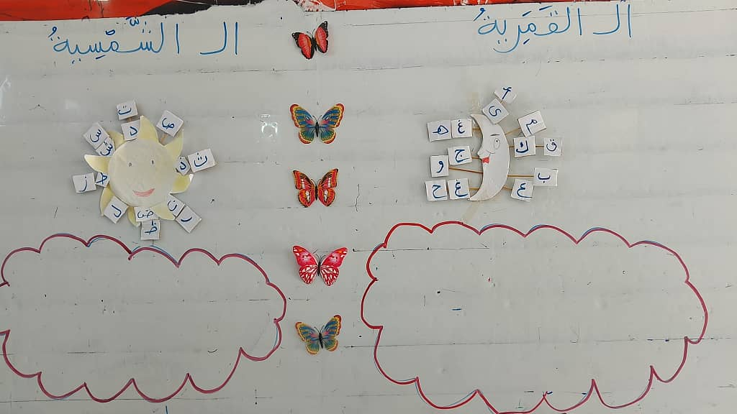
Putting words with ‘the sun [al-]’ and words with ‘the moon [al-]’ in a box so that the learner has to choose a word, read it correctly and then decide whether it is a sun [al-] or a moon [al-] word. They then associate it with the appropriate model.
Then 3 letters were written on the board.

ح
ب
ر

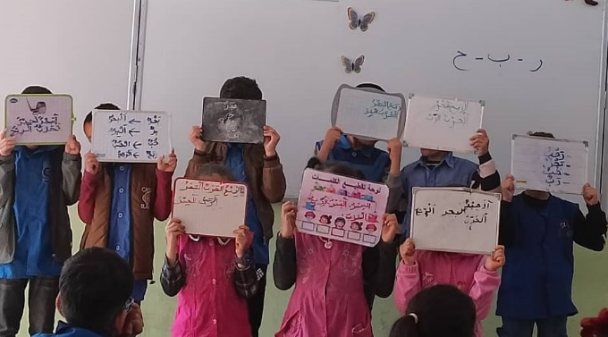
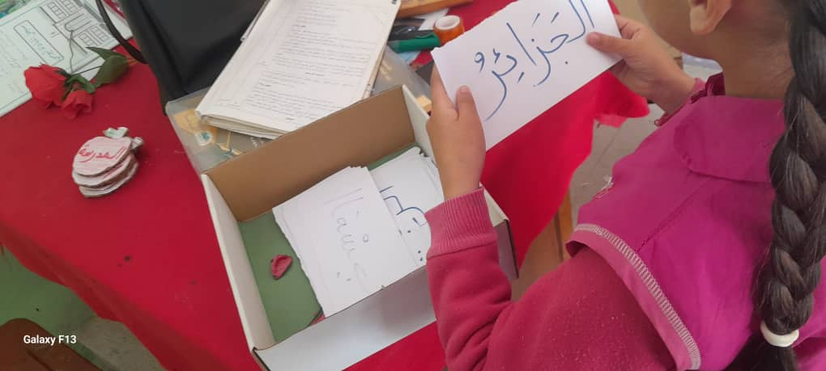
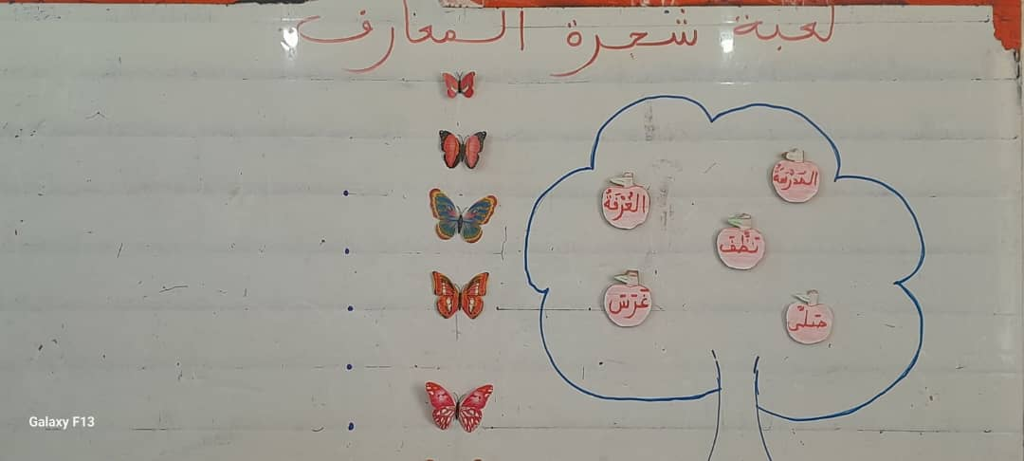

The students were asked to form words
with these letters and then add the article “al-“ to them. The learner who makes the most words is the winner of the game.
This is what is known as the system of permutations according to Al-Khalil bin Ahmad Al-Farahidi. In this way, the students enjoyed the lesson in an atmosphere of excitement, competition and fun.

2. The Tree of Knowledge game: A tree was drawn on the board and fruits were attached to it with the following words written on them

Plant

Cleaned

Prayed
Room
School

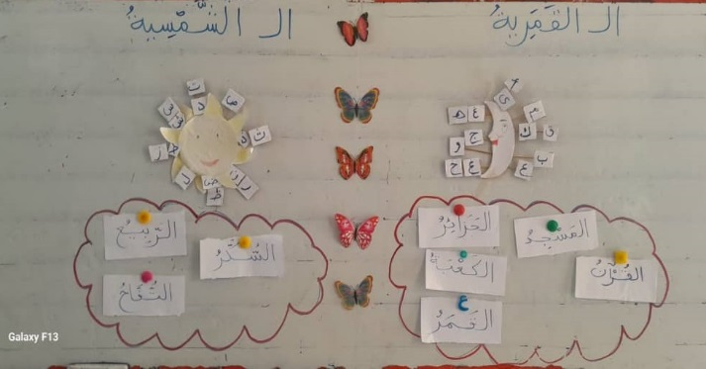
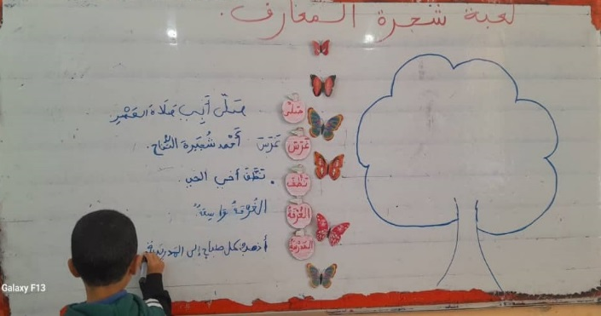
The students then come up one by one to pick a fruit, read it and then form a sentence.
The sentences formed are:
My father performed the Eid prayer.
Ahmed planted an apple tree.
My brother cleaned the neighbourhood.
The room is big.
I go to school every morning.
The purpose of this game is to measure the students’ ability to form sentences, develop their language repertoire, enrich their knowledge of word meanings and use them effectively to construct meaningful sentences and phrases. It also indirectly trains them in reading and writing.

3. The “letter discovery” game: This is done through several models of language games.
Step One:
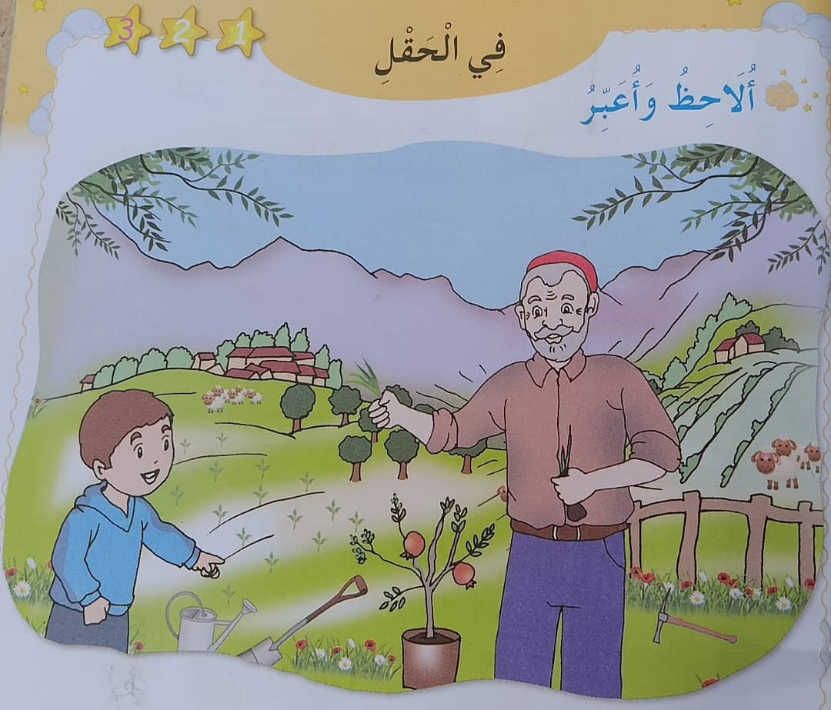
The lesson began with an oral session in which the teacher reminded the learners of the letters being studied as an introduction to the lesson and to focus the learners’ attention. The learners were then instructed to observe the picture or scene.

With precise and direct guiding questions related to the spoken text, the teacher asked the following question
What has Ahmed planted? Then the intended sentence expressed by the learners’ voices is extracted, i.e:
“Ahmed planted a lemon tree”. The question and answer game is one of the educational games that develop speaking and listening skills.

Second step:
The teacher writes “Ahmed planted a lemon bush” on the board, then the sentence is repeated, first by the teacher, then by the learners, with the appropriate intonation, taking care to pronounce the sound segments within the structure correctly, in order to link the auditory image with the visual image.

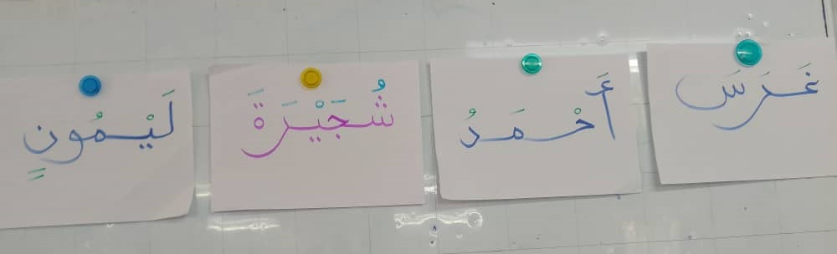
Step three:
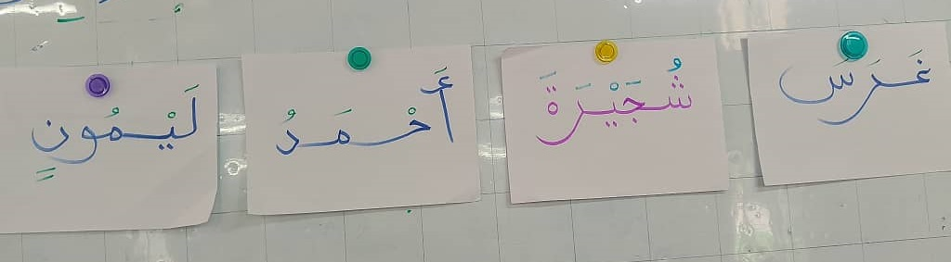
The teacher instructs the learners to put their heads on the table and then proceeds to scramble the words within the sentence.
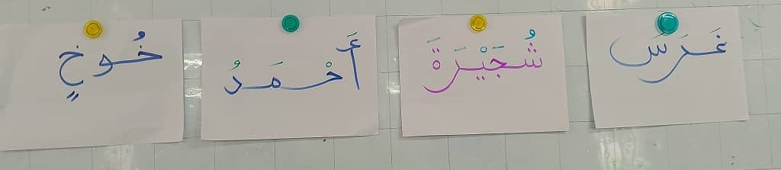

Then the teacher asks the learners to rearrange the sentence again, the aim of this step is to get the learners’ attention and to strengthen their focus during the lesson. The teacher then practises the substitution pattern within the sentence by replacing the word ‘lemon’ with the word ‘peach’.

And here,
the teacher has added another piece of knowledge to the learners, in addition to teaching them how to construct new sentences by substituting one word for another, and has reached the point where the change in structure inevitably leads to a change in meaning.

The fourth step:
In this step, the teacher gradually removes the elements of the previous sentence, keeping the target word “bush”, and asks the students to segment the word into sound syllables, once on the blackboard and once with the clapping mechanism. After segmentation, the teacher makes a gradual deletion of the sound syllables, keeping only the target unit of the lesson, “the letter Shin”.

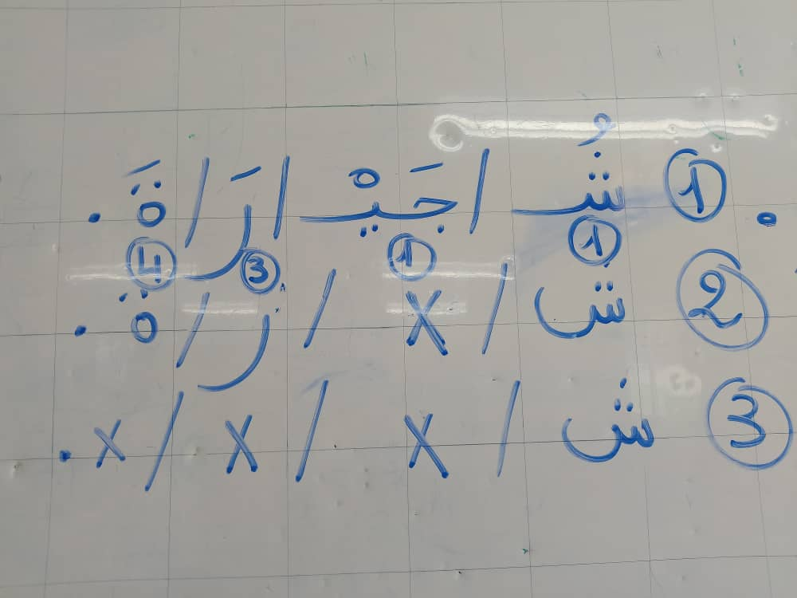
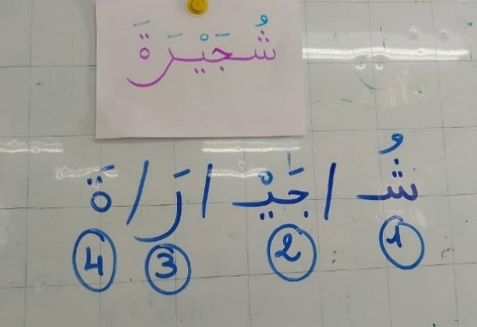

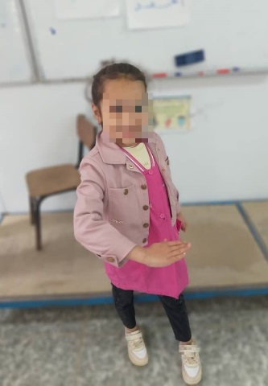
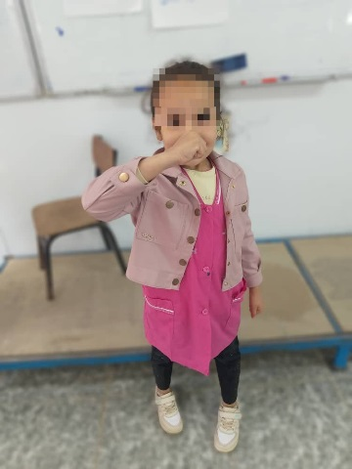
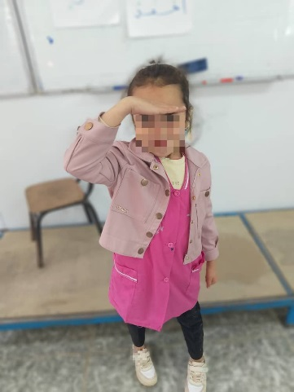
The learners enthusiastically welcome the new letter and read it for the first time as a silent letter with the aim of identifying the point of articulation and correcting the pronunciation, then they read it with its different vowel marks by vocally responding to the letter with hand movements as shown in the picture.
شَ
شِ
شُ

The purpose of reading the letter with hand motions is to control the movement of the learners within the classroom, in addition to the fact that many learners find it difficult to associate the letter with its sound, so the teacher tries to activate the motor skills in order to improve the spelling and correct reading of the letter.
From this we can conclude that the second generation curriculum for the Arabic language has attached great importance to what is known as phonological awareness, so that the learner knows that the spoken linguistic units are a composite mould of several parts (consonants, vowels) and not a single sound unit, and this helps the learner in the process of correct pronunciation and correct reading.

4- Word game:
The teacher selects 4 students who form a circle and asks each of them to form a word with the letter “Shin” within a given time, with the condition that the word may not be repeated, and whoever fails to form the word is considered a loser in the game until only one student remains who is considered the winner.
This game is a special activity that aims to motivate the students, train them to form words, activate their mind and revive their memory, as well as teaching them to respect and manage time in a fun and entertaining way.

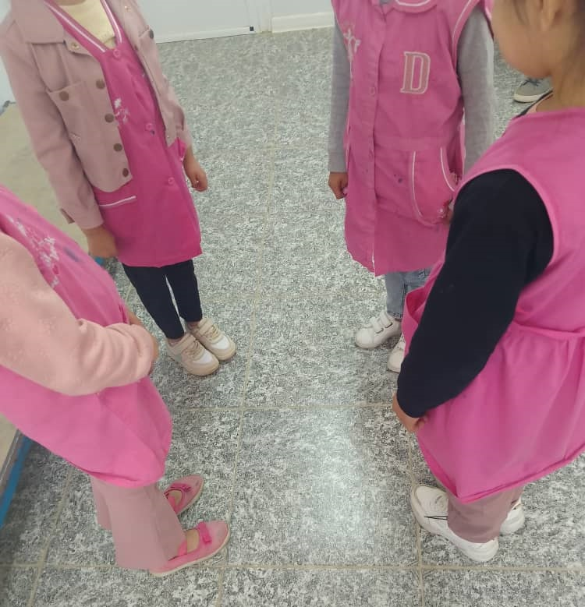
5 - Letter position game:

The jumping game:
The teacher gives the students words containing the letter ‘shin’: ‘شمس’ (sun), ‘عشب”grass),فرشاة “brush”
And words containing the letter ‘sin’: ‘سلحفاة’ (turtle), ‘سكر’ (sugar), ‘وسائل’ (means)
to test their ability to differentiate between the two letters, which are similar in spelling and pronunciation. This also helps to identify the position of the letter ‘shin’ in the word. The teacher places three blue rings on the floor and one orange ring and asks the students to read the words; the students jump on the appropriate blue ring (beginning, middle or end of the word) depending on where they hear the ‘shin’ letter, and on the orange ring if the word contains the ‘sin’ letter. Students who make mistakes are considered losers in the game.
The purpose of this game is to exercise muscles, develop mental processes, increase motivation to learn and build skills in speed, accuracy, execution and listening comprehension.
The teacher then asks the students to close their eyes and listen while the teacher reads words containing the letter ‘shin’ “شيماء’’, ‘منشفة’, ‘مرش”,
if the ‘shin’ is at the beginning of the word, the students put their hands above their heads, if it is in the middle, they put their hands on their stomachs and if it is at the end, they lift their feet. The pupils are then asked to write the words on their blackboards, with diacritical marks, in a quiet and concentrated environment.

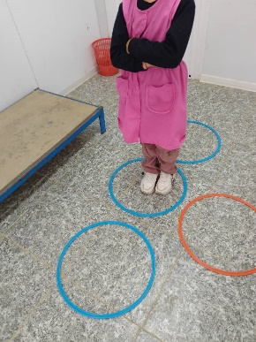
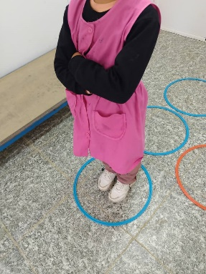
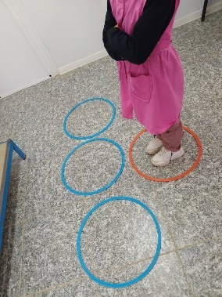
الشين في أول الكلمة
الشين في وسط الكلمة
الشين في آخر الكلمة
كلمة فيها حرف السين

صورة صورة صورة

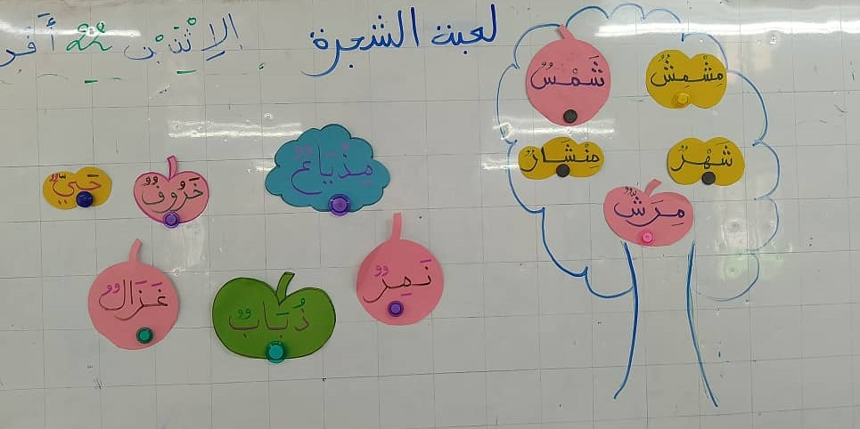
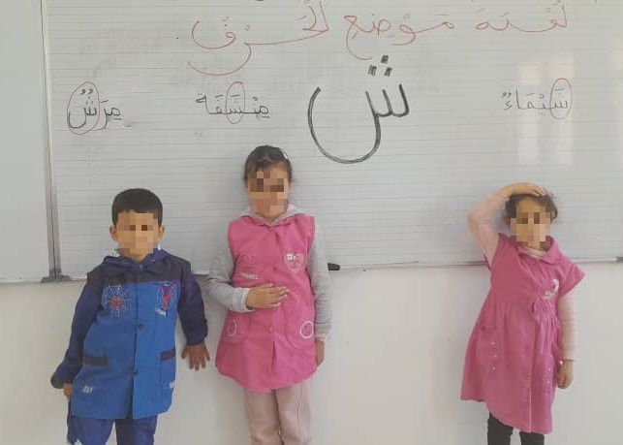
The aim of this game is to train muscles, develop mental processes and achieve motivation to learn. It also aims to teach speed, accuracy and mastery in execution, as well as developing listening skills.

The teacher asks the students to close their eyes and listen. They read words containing the letter "sh" (such as chaima شيماء, towel/منشفة (minchafa), مرش(marash)/spray) and if the "sh" sound is at the beginning of the word, the learners put their hands on their heads. If the 'sh' sound is in the middle of the word, they put their hands on their stomachs. If the 'sh' sound is at the end of the word, they lift their feet. Then the teacher asks them to write the words on slates with diacritical marks, in an atmosphere of silence, concentration and attention. The aim of this game is to develop the four

language skills (listening, speaking, reading, writing) and to control the movements of the pupils, since physical control necessarily leads to mental superiority.

The tree game:
The teacher draws a tree on the board and then chooses a student in each round to pick a fruit from the apples hanging on the board with words written on them. The words that contain the letter ‘Sheen’ are placed inside the tree, while the words that do not contain the letter ‘Sheen’ are placed outside the tree. The aim of this game is to develop the students’ reading skills and to fix the letter in their minds.
The teacher has also used written models with his students, trying to develop handwriting and writing, such as
- Adding a new word by adding the studied sound syllable to the word suggested by the teacher:
مال… (…mal) → شمال (shimal)

- Substitution:
Replacing the sound syllable (Dal) with the sound syllable studied (Sheen) to form a new word.
دموع (doumou’) → شموع (shumuu3)

- Isolation:
To isolate the sound (Sheen) from the other sounds in a single word.
شمس (shams), شراب (sharab), شجرة (shajara)

- Recognition:
Recognising a word that begins with a sound unit that is different from the rest of the words.
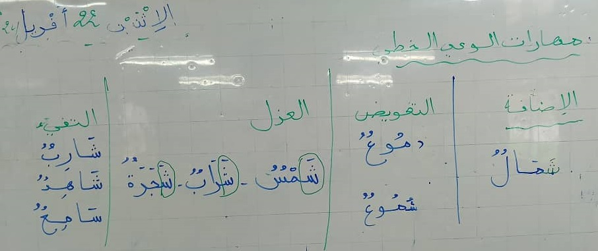
شارب (sharib), شاهد (shahid) . سامع(sami3)

6 - The clock game: The object of this game is to assemble words divided into two syllables by the following steps:
A cardboard clock is placed with twelve pieces, each with half a word written on it. The learner moves the small, thick hand towards the first syllable and the long, large hand towards the second syllable of the word, thus obtaining a complete word, which they then read and write on the board. They then divide the word into sound syllables with their fingers and number them. This game helps to link the syllables of a single word and the correct written form of the word, to avoid spelling mistakes and to develop both reading and writing skills together.

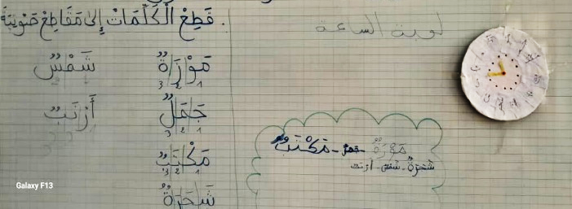
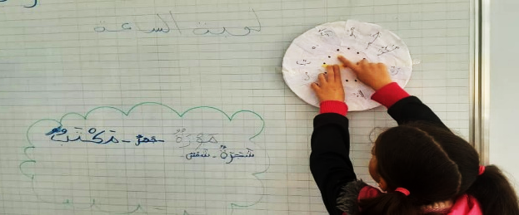

Conclusion:
Language games play a positive role in raising the educational level of learners, especially in the early stages of learning. They have greatly contributed to the success of the teaching-learning process and to the achievement of the educational objectives sought by the competent authorities. We have concluded from the above that
- Play is a popular activity for primary school children because it helps them to imagine, visualise and be creative through its elements of excitement, fun and entertainment.
- Language games have cognitive, emotional, psychological and behavioural objectives that help learners in the teaching-learning process, to express their thoughts spontaneously and also to increase their linguistic repertoire.
- Language games encourage problem solving and overcoming linguistic difficulties, as well as reducing learners’ confusion and anxiety during their learning practice.
- Language games play an effective role in teaching the Arabic language at all its different levels (listening, speaking, reading, writing), especially at the primary level.
- Language games encourage learners to participate, cooperate and communicate with each other, especially in group games. They also give them courage and make them aware of some of the difficulties and disabilities that only this type of learning can reveal, such as autism.
- Linguistic games create an atmosphere of fun and joy in the classroom during their collective interaction.
- Linguistic games take into account individual differences.
In the light of the results obtained, we propose the following set of recommendations
- Carry out training courses to encourage teachers and make them aware of the importance of using language games in their classrooms, especially for primary school learners, and how to implement them. This will have a positive impact on learners’ progress in language learning, as well as increasing their motivation and developing their skills.
- To work on the design and production of new language games that are in line with the psychological, mental, social and intellectual characteristics of learners in different fields, in new methods and forms that are in line with the literature of modern education and benefit from the latest research in this field.
- Using language games as part of digital learning techniques and studying their effectiveness in motivating learners and improving their learning.
- The use of language games as a means of creative expression and social interaction in psychological treatment.

List of sources and references:
- Ahmed Latman, Khaled bin Umayr, The Importance of Language Games in Developing Reading and Writing Skills among First-Year Primary School Students, Journal of Problematic Language and Literature, University of Mohamed Seddik Ben Yahia, Algeria, 2022, Issue 1.
- Asmahane Loubadi, Hajira Faqrish, Language Games and Teaching the Arabic Language, Master’s thesis submitted as a requirement for the Master’s degree in General Linguistics, University of Mohamed Boudiaf, Msila, 2019/2020.
- Hamed Abdel Salam Zahran, Language Concepts in Children, 1st edition, Dar Al-Masirah for Publishing and Distribution, Amman, Jordan, 2007.
- Zouhair Khalif, Integrated Educational Games, 1st edition, Aws Educational Network, Palestine, 2009.
- Zainab Jamal El-Din Qashta, Employing the Strategy of Scientific Stations and Educational Games in Developing Creative Thinking in Science among Seventh Grade Students, Master’s Thesis, Department of Curricula and Training Acquisition, Islamic University College of Education in Gaza, 2008.
- Abdullah Rabihat, The Effectiveness of the Language Games Teaching Strategy in Developing Speaking Skills in the Arabic Language Subject for Fourth-Grade Students, Journal of Educational and Psychological Sciences, Periodical of the National Center for Research, Palestine, 2017, Issue 6.
- Faten Ibrahim Salut, The Impact of Employing Educational Games in Discriminating Between Letters Similar in Shape and Different in Pronunciation for Second-Grade Students, Master’s Thesis, Department of Curriculum and Teaching Methods, Faculty of Education, Islamic University, Gaza, 2010.
- Mahmoud Al-Hila, Educational Games and Techniques for Producing Them, 1st edition, Dar Al-Masirah for Publishing and Distribution, Amman, 2002.
- Nasser Moustafa Abdel Aziz, Language Games in Teaching Foreign Languages with Examples for Teaching Arabic to Non-Native Speakers, 1st edition, Dar Al-Marikh Publishing, Riyadh, Saudi Arabia, 1983.

- Nasif Moustafa Abd Al-Aziz, “Linguistic Games in Teaching Foreign Languages with Examples for Teaching Arabic to Non-Native Speakers”, 1st edition, Dar Al-Muraykh for Publishing, Riyadh, Saudi Arabia, 1983, p. 13.
- Hamed Abd Al-Salam Zahran, “Linguistic Concepts in Children”, 1st edition, Dar Al-Maseera for Publishing and Distribution, Amman, Jordan, 2007, p.320.
- Faten Ibrahim Salwat, “The Impact of Utilizing Educational Games in Distinguishing Between Letters that are Similar in Form and Different in Pronunciation for Second-Grade Students”, Master’s Thesis, Department of Curricula and Teaching Methods, Faculty of Education, Islamic University, Gaza, 2010, p.28.
- Ibid, p.28.
- See, Zouhair Khalif, “Integrated Educational Games”, 1st edition, Ous Educational Network, Palestine, 2009, p.3.
- Zaynab Jamal Al-Din Qashta, “Employing the Strategy of Scientific Stations and Educational Games in Developing Creative Thinking in Science for Seventh-Grade Students”, Master’s Thesis, Department of Curricula and Training Acquisition, Islamic University College of Education, Gaza, 2008, p. 03.
- Abdullah Rabehat, “The Effectiveness of the Teaching Strategy of Linguistic Games in Developing Speaking Skills in Arabic Language for Fourth-Grade Students”, Journal of Educational and Psychological Sciences, Periodic, National Center for Research, Palestine, 2017, Issue 6, p.19.
- Asmahen Labadi, Hadjira Fekraoui, “Linguistic Games and Teaching the Arabic Language,” Memorandum submitted as partial fulfilment of the requirements for the Master’s degree, specialisation in General Linguistics, University of Mohamed Boudiaf, M’sila, 2019/2020, p.42.
- Mahmoud Al-Hila, “Educational Games and Techniques for Producing Them”, p.56.

